**DAILY ONLINE ACTIVITIES SUMMARY**

|  |  |  |  |  |  |  |  |
| --- | --- | --- | --- | --- | --- | --- | --- |
| **Date:** | **28/05/2020** | | | | **Name:** | **Ravi K R** | |
| **Sem & Sec** | **8th- B** | | | | **USN:** | **4AL16CS076** | |
| **Online Test Summary** | | | | | | | |
| **Subject** | | **SMS** | | | | | |
| **Max. Marks** | | **60** | | **Score** | | **60** | |
| **Certification Course Summary** | | | | | | | |
| **Course** | **Ultimate java development and certification course** | | | | | | |
| **platform** | | | **Eduonix** | **Duration** | | | **20 hours** |
| **Coding Challenges** | | | | | | | |
| **Problem Statement:**  **1)** Given an array of integers, return **indices** of the two numbers such that they add up to a specific target.  You may assume that each input would have **exactly** one solution, and you may not use the same element twice. | | | | | | | |
| **Status: Executed** | | | | | | | |
| **Uploaded the report in Github** | | | | **Yes** | | | |
| **If yes Repository name** | | | | <https://github.com/alvas-education-foundation/Ravi_kr> | | | |
| **Uploaded the report in slack** | | | | **Yes** | | | |

Online Test Details:

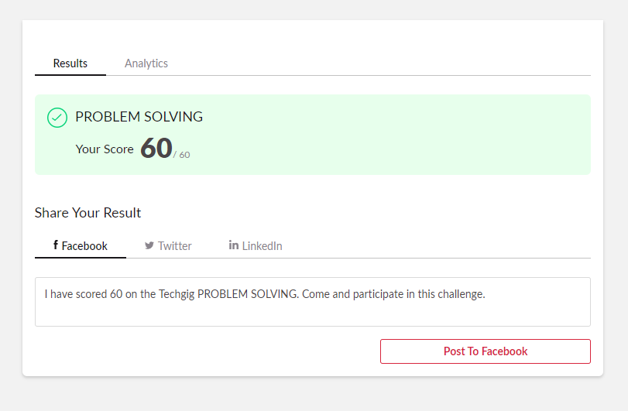

Certification:

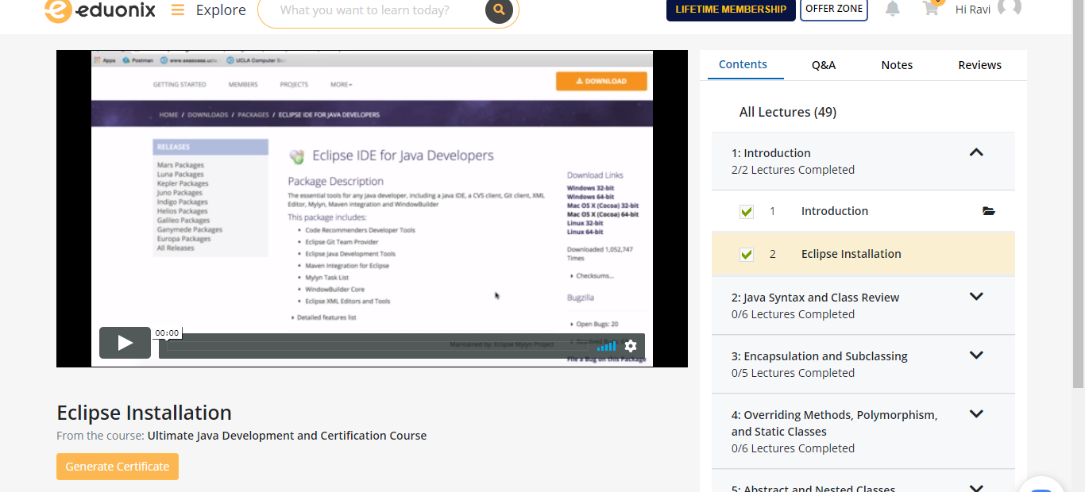

Coding Challenges Details:

